Fundamental or technical analysis, when people want to choose where to invest they use an of this techniques. You can use both to see how to make more money.

Fundamental analysis is the study of what the company is actually worth, buying a good at cheap rate before the market realises they have sold it at a cheap

Trading without knowing if wrong or right u need to know how to keep the losses controlled.

Ok everyone is doing it so the price falls then you try to be positive then hope then optimism, then they forget that.

If you are trading because people say its good to trade and even taxi driver says its good to trade and you dnt want to miss out you trade, that’s trading out of fear. Its bad practise.

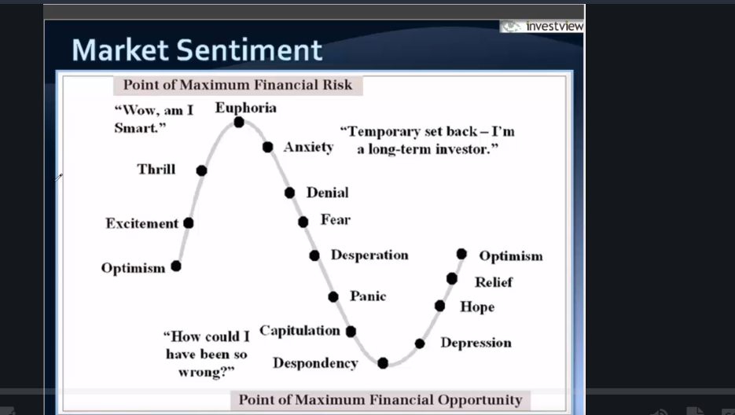

Different types of traders

Day traders want a trade for a day. And profit as it falls maybe 2hr or 30 mins very short term basis.its the most difficult way to make money. Monitor constantly

Swift traders, buy it and sell a week later when it meets their targets. They dnt monitor their screen

Position trader.. nuy sell 8 weeks later more money like swift.

Investor: looking at the fundamentals …what are values , equity, but you are looking for the warren buffet philosophy find under valued companies trading at a durable competitive advantage. Coca cola, it has a spot where every company uses it. long term. Upaate when company announces their earnings.

In technical analysis two big factors

1. Price action – price is key focused on supply and demand. If business is strong then price action is positive and if price action is positive then I want to buy .
2. Volume

Price action (price pivot is trying to take control between buyers)

Buyers try to push the price upper and sellers trying to push the price back down.

Minor pivot

Intermediate pivot

Major pivot

Trends start as a minor pivot nothing major happens then once the dynamic shft. Pivot is associated with support vs resistance levels.

As long as the sellers are pushing the stock price down

When 90 or 100 then it will sell hard

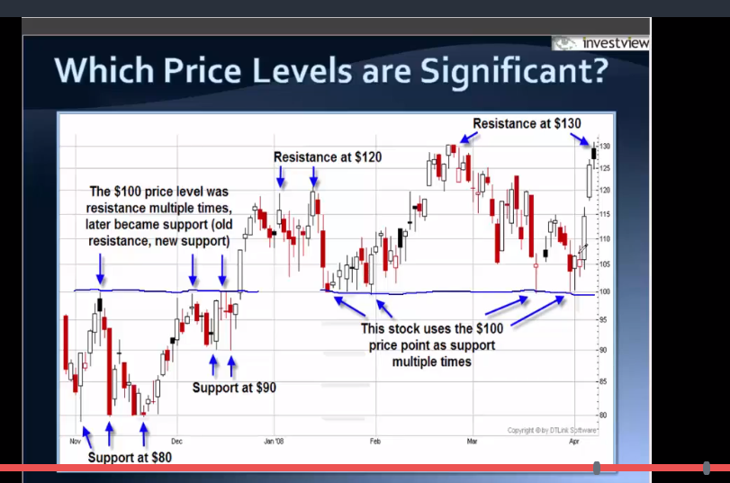

Support when broken becomes resistance and when resistance is broken it becomes support.

Technical analysis is about spoting supply and demand

A trend is to move in a general direction

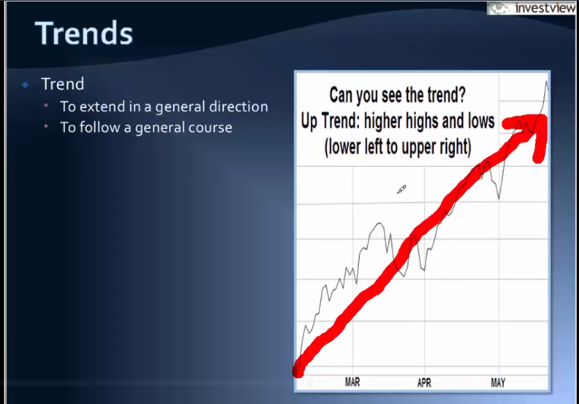

Its moving up

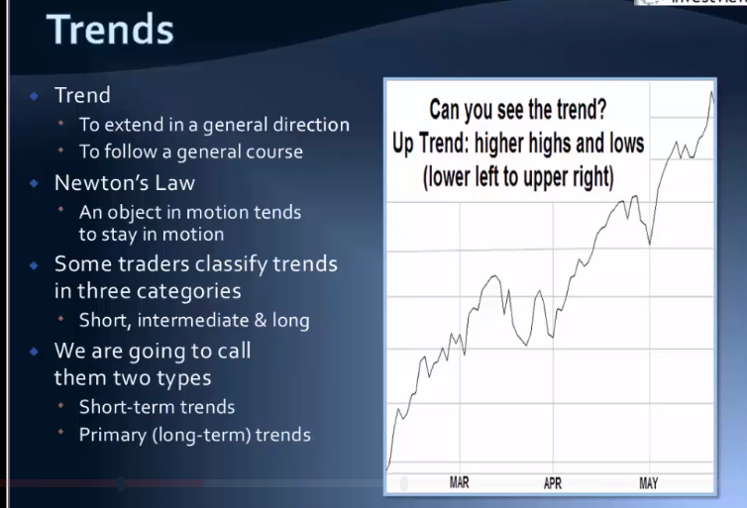

There are long and short trends

Short term trend talks about minor pivots.

Long term trend starts to roll over so trend changes when stocks starts making pivot in a new direction.

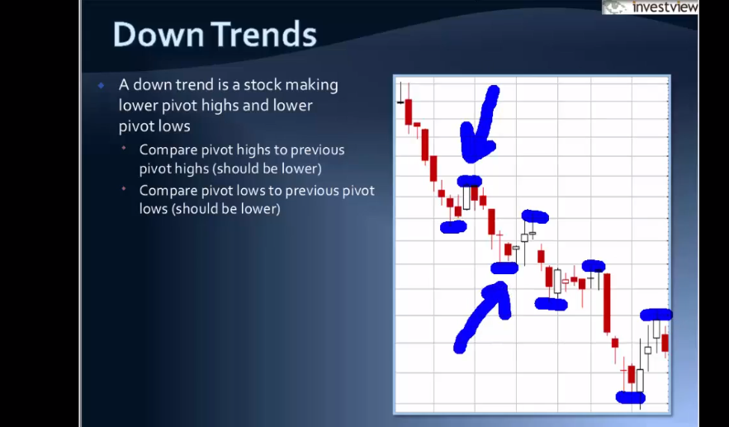

Stocks are dropping because more people are buying and selling.

Trend changes when stock breaks higher so more demand than supply. So study pivots …..

Study resistance and support.

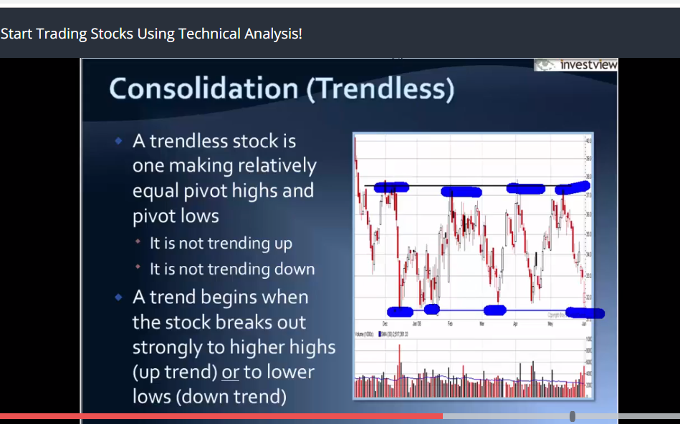

No momentum .

Long term primary trend lines are never broken but short can be broken which Is huge.

Bull market chart know it

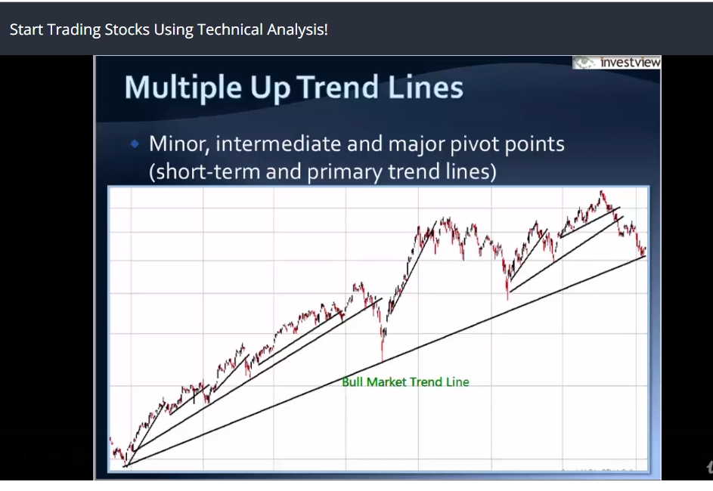

Below bull market line is good (bare market) we want to buy.

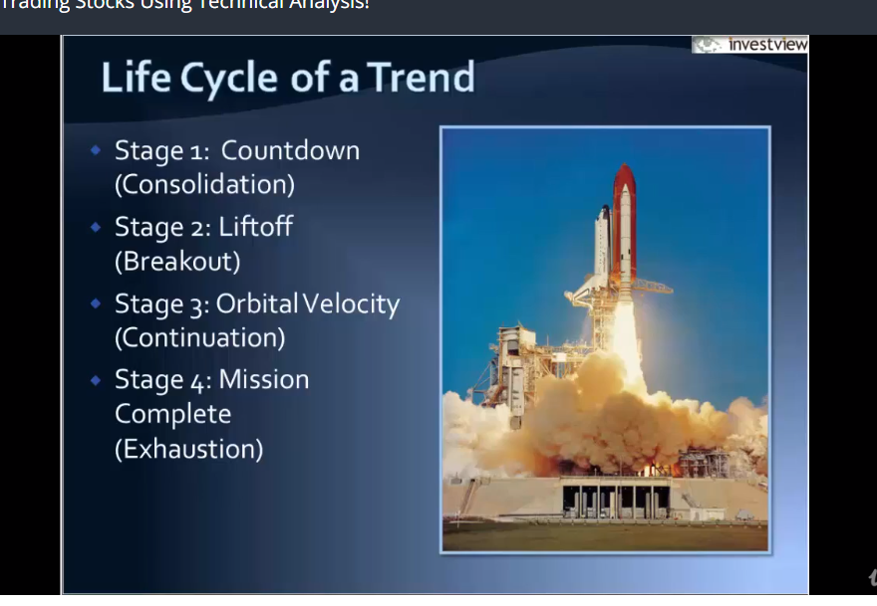

Consolidationis when its same level no momentum

Break out: perfect trading this is good time to buy

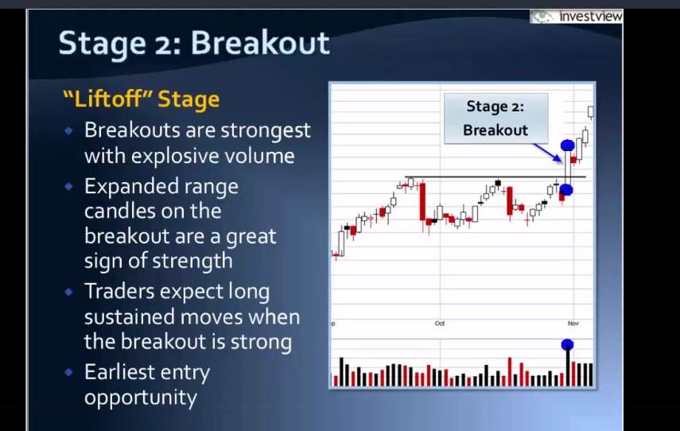

Orbital velocity: continuation… dnt bet against trends its going upside no need to bet get it. Swing traders try to make their move here.

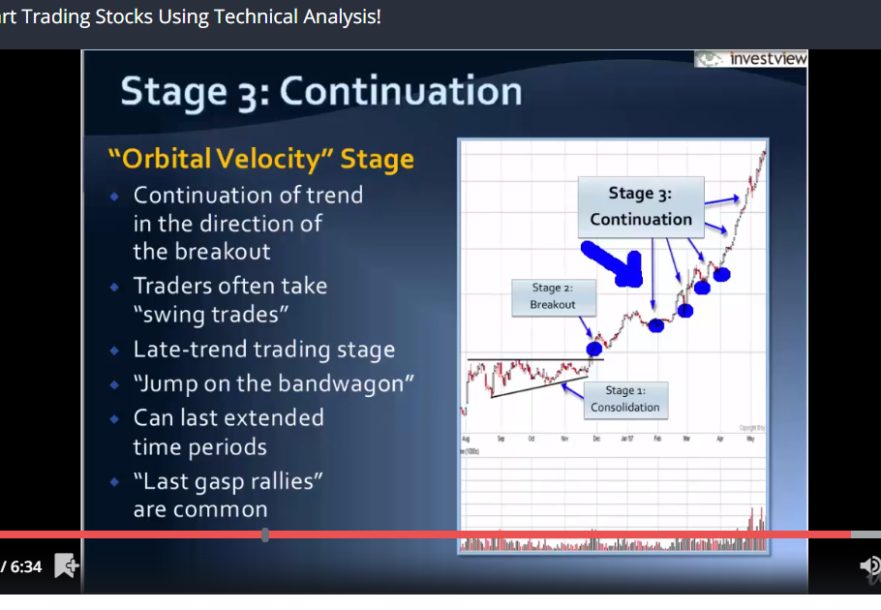

Then the trend runs out of steam, volume surges it’s a problem for the market.

Question,

What can you tell from this trend

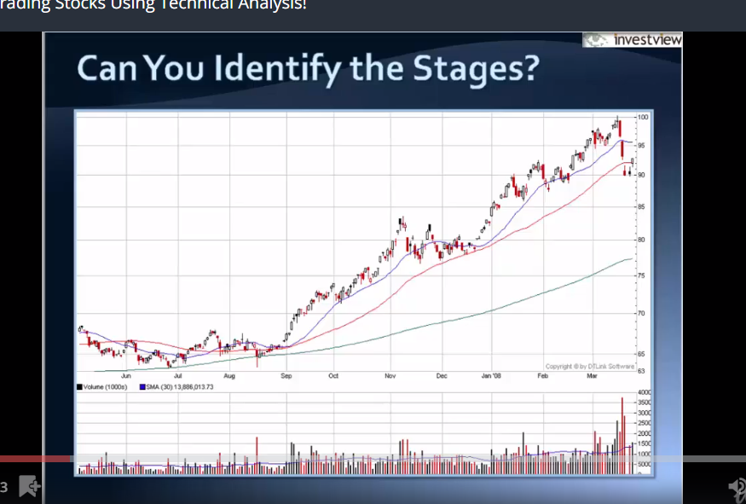

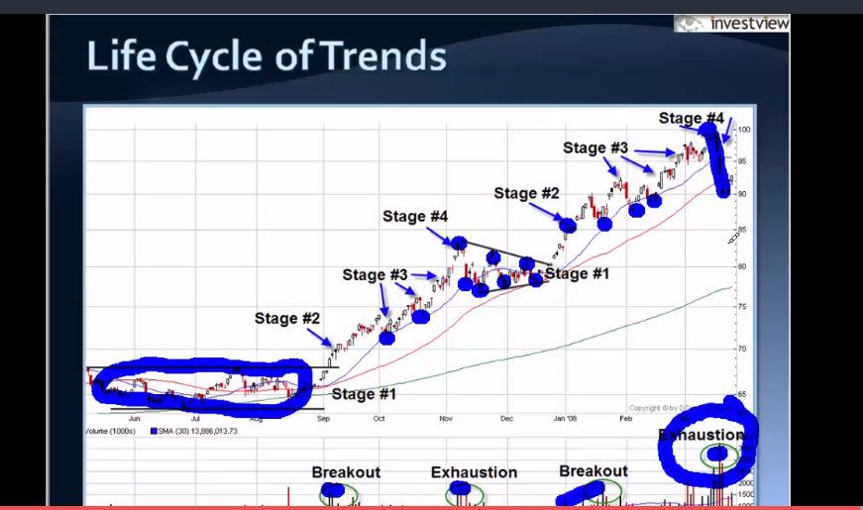

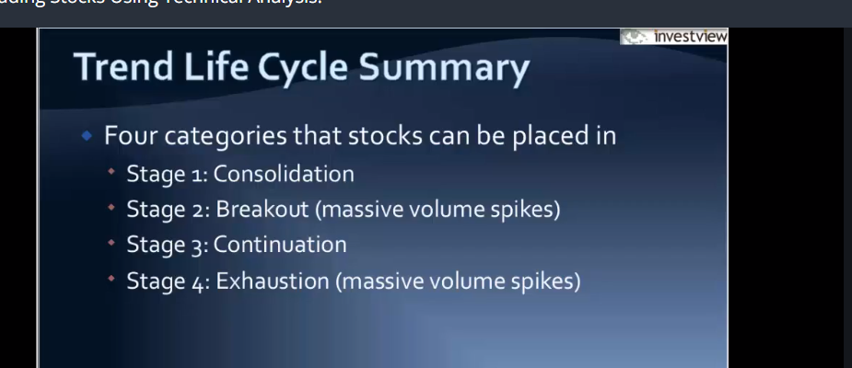

Capitulation …avoid buying bio tech stuff. Gaps are caused by an event .

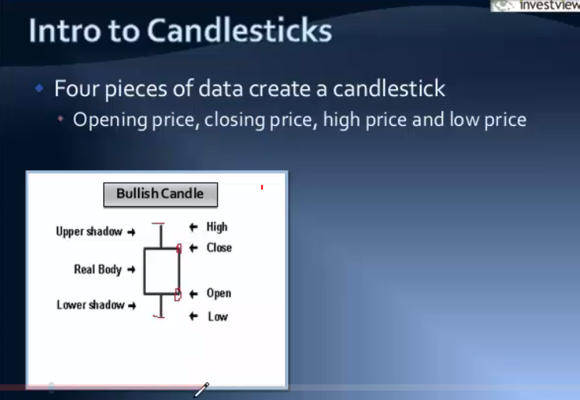

Market opens from 9 .30 to 4.30 eastern time. Japanese started this style of trading

If closing price is higher than the open what can we say about the price action, we can say buyers where more aggressive and buying out paste selling

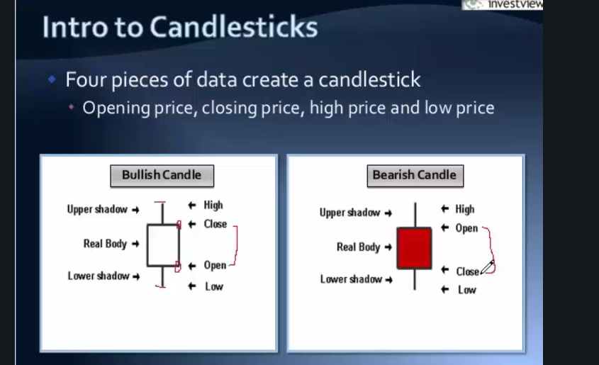

The body is what you look at

This is the candle formation to buy

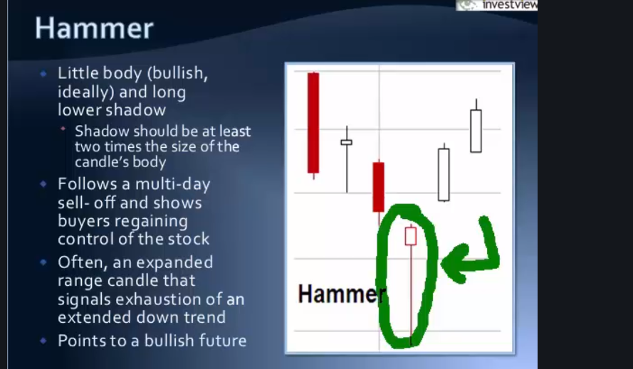

Google when to buy and sell

ATR is Average True Range….

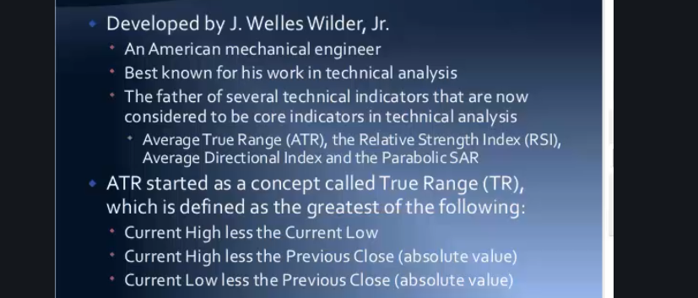

Now every reader has an atr reader so find it and click it and it will show the graph

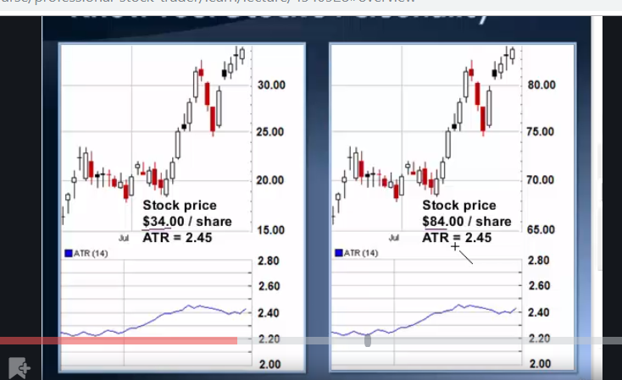

Left is more volatile

Note higher atr is more volatile.

Use ATR to understand the stocks personality

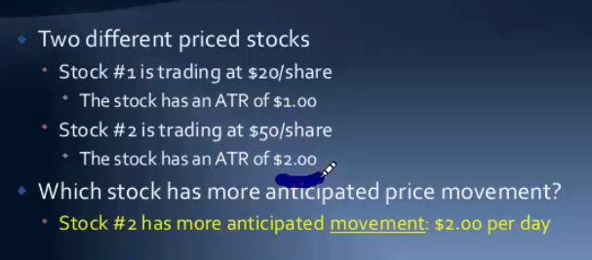

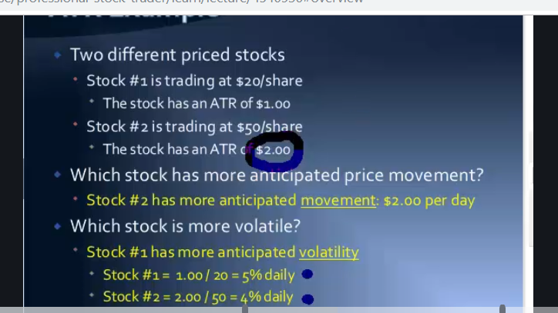

What is volatility stock?

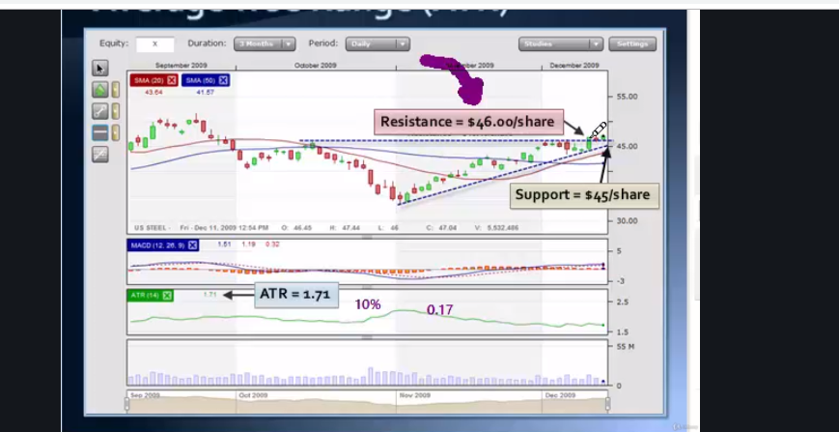

If resistance is 46, we want to buy at 46.17

Calculate stop loss how?

Volume… like loud noise aggressive buying or selling drags attention

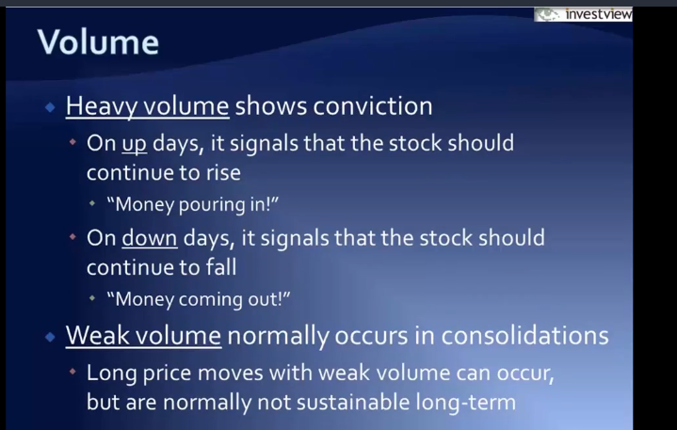

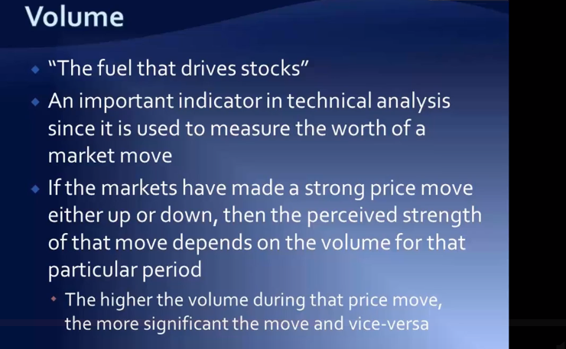

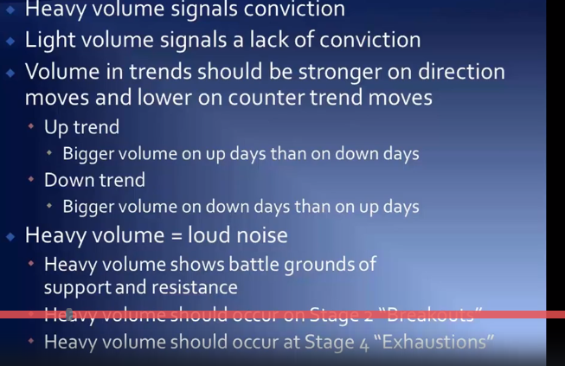

Investors use quarterly basis to see trend change which is the 50 day moving average. So above 50 is up trend and below 50 is down trend.

Also traders use 20 days as support or resistance guiding.

50days can act as support or resistance guide.

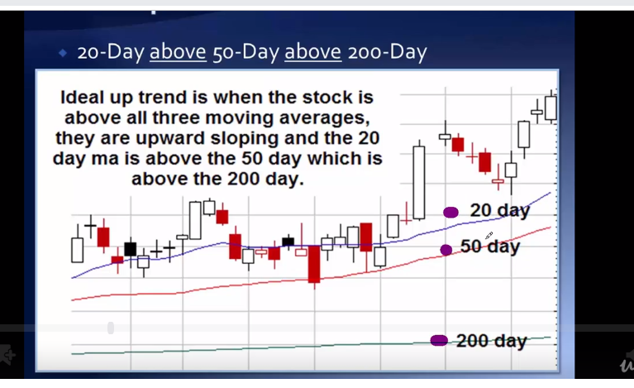

Uptrend

When the red crosses the blue, u buy

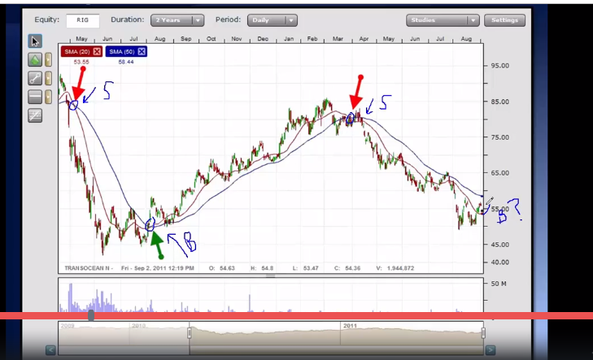

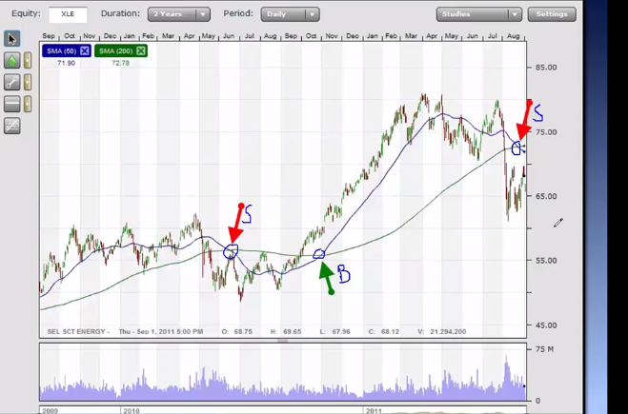

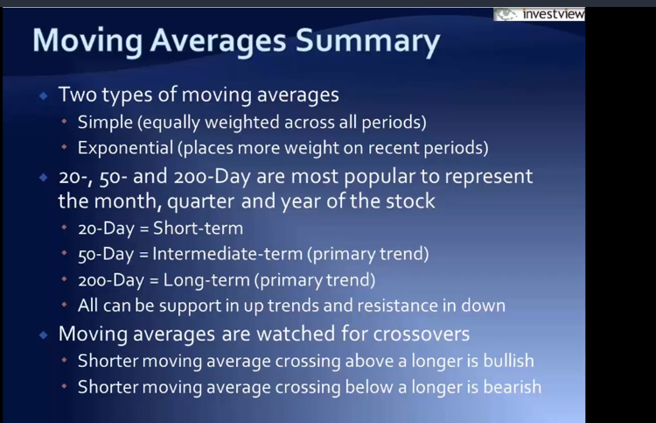

Bearish 50 below 200

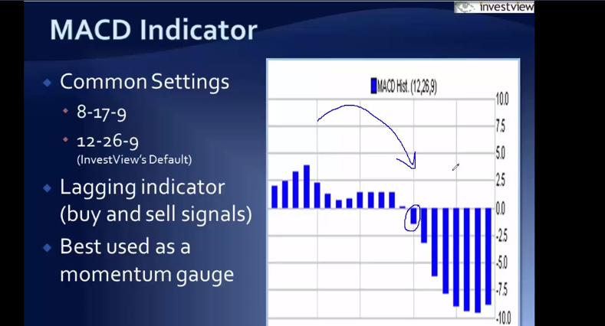

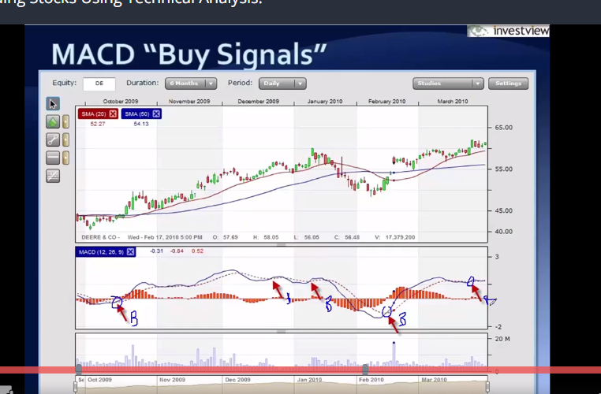

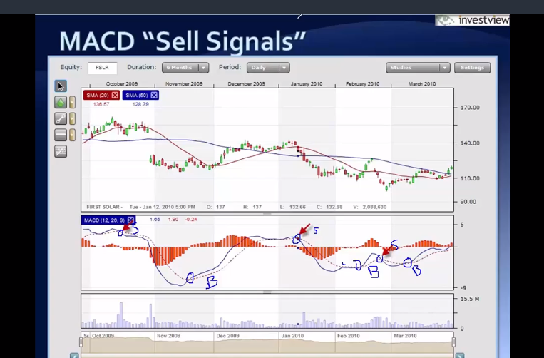

Not a big fan of MACD he said little or no success

But MACD converging and diverging is the best for prediction

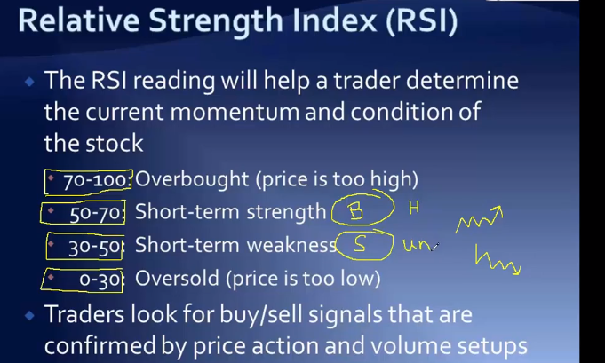

Traders call confirmation meaning

The Single most important idea to making money

Risk and Money management: this is the backbone of making money.

Now breaking down the market

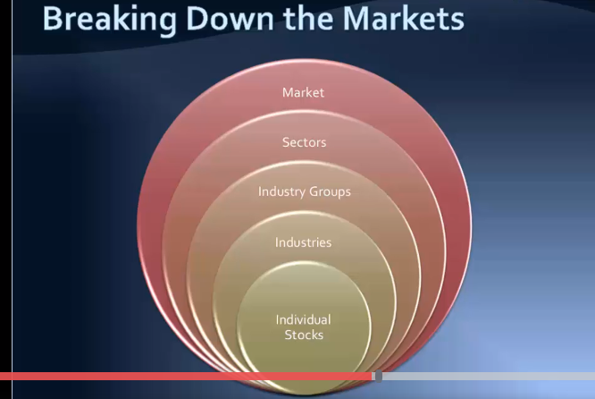

Sectors are different things within the market finance companies,

Broad markets….

There are four major companies in the us

1. S and P 500 which consists of the 500 major companies
2. Every one focuses on s and p. The bench mark.
3. Nasdaq…technology companies
4. Small businesses Russel 2000 but s and p is called the market coves more

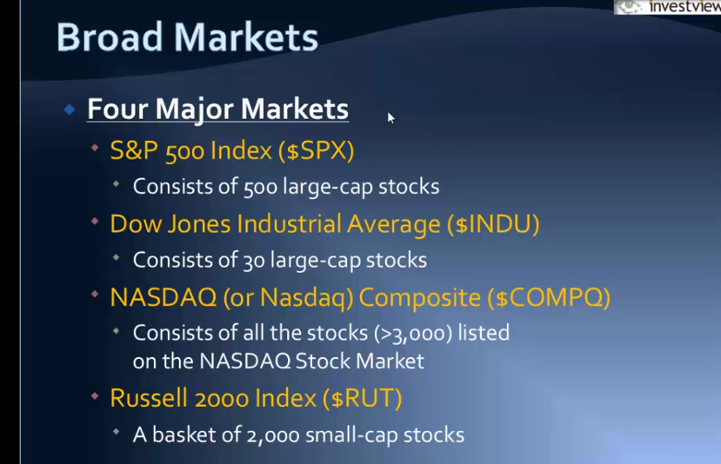

What is etf?

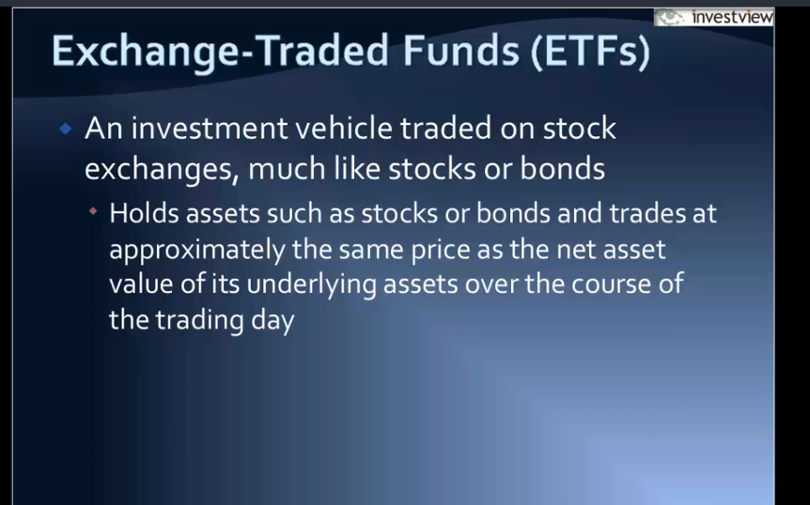

Etf are great for diversification and traders love it and good for analysing market.

There are four major ETFs

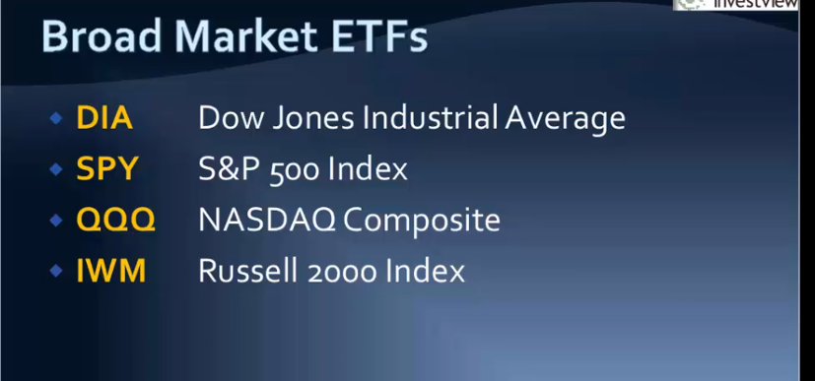

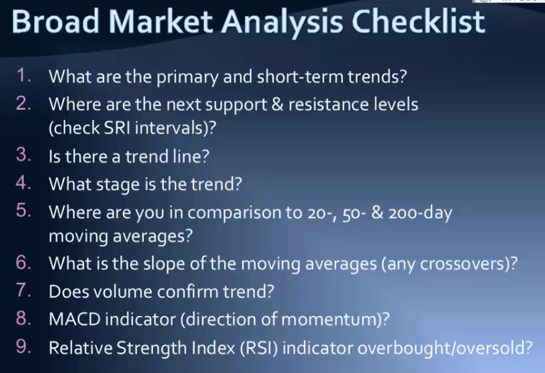

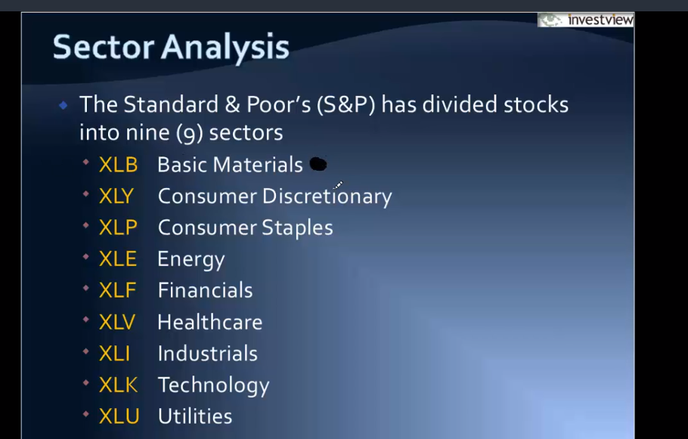

Materials include gold mining companies, copper companies, chemical companies, consumer discerptionally companies, when u have extra money nike, Disney

Consumer staples thung u cant live without procter and gamble

Energy…oil natural gas coal

Financials..big banks, financial companies, insurance companies

Health care: Biotec phamaceuticals,

Industials: general electric caterpillars

Technology: google ,apple, amazon

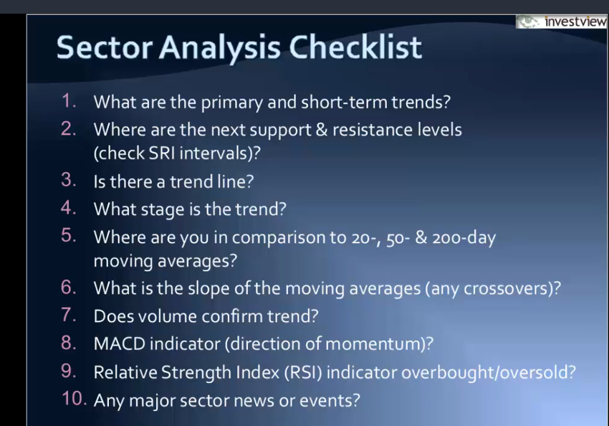

We need to know the trend the momentum, the volume, he stage of the trend , the indicators

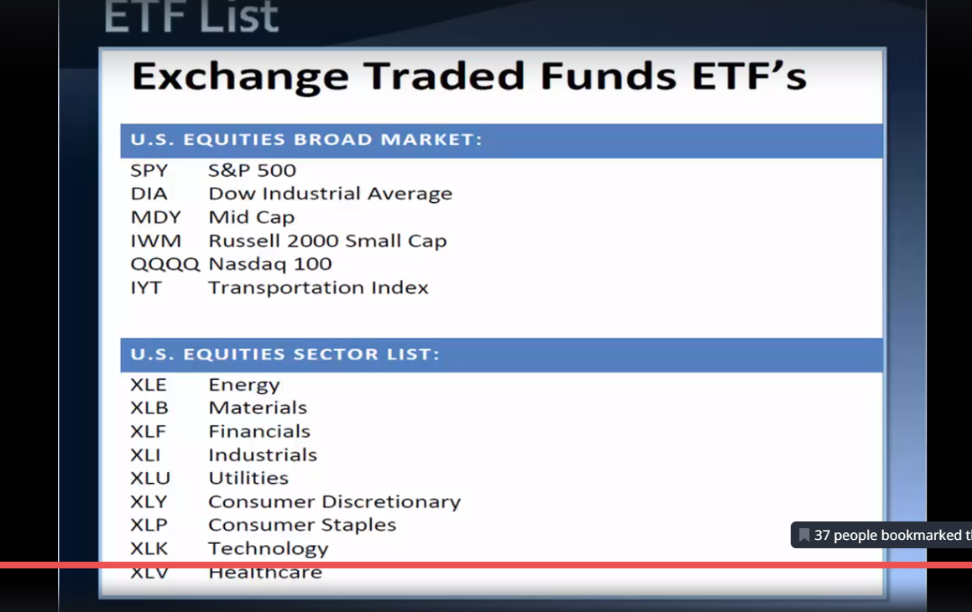

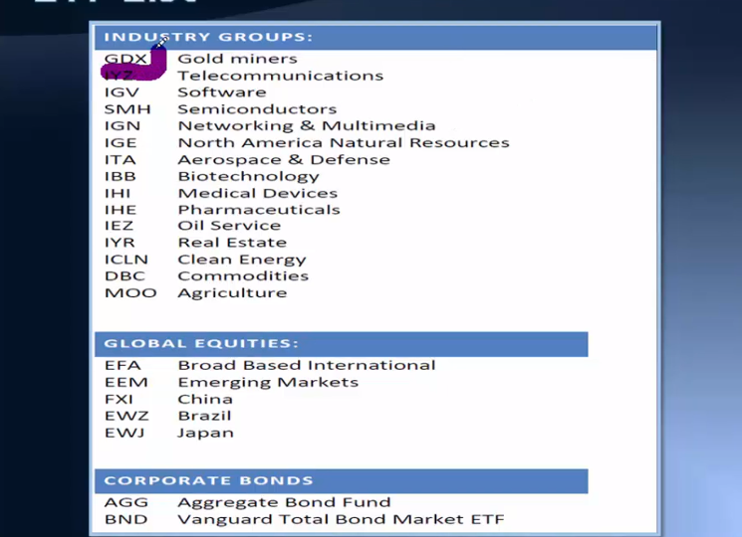

Trading and analysing etfs.

Money managements

How much am I willing to risk in every trade ?

Stop loss, to risk a small portion……

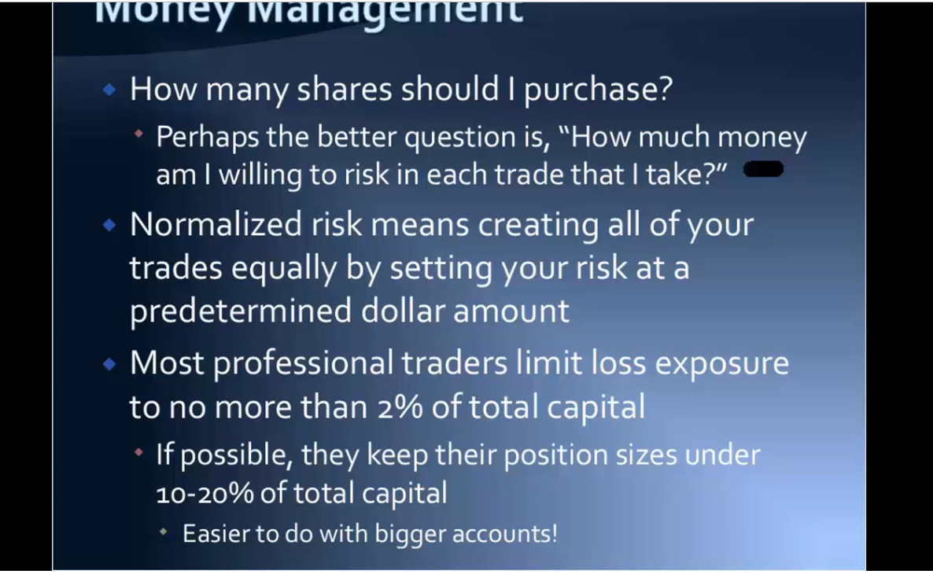

If you have 100 grand to trade, 2% is 2 grand that’s your risk stop.

Money grows with your knowledge

NO trade should be bigger than any . every trade should be seemingly insignificant

Position size,

Under 10 to 20 % means if u have 100 grand to trade, you shouldn’t invest more than 10 to 20 k on any stock

Diversification

Now if you are starting your business with 1 grand you are not going to be buying stocks or shares you would be trading vehicles, options, futures to start off,

By s and p index fund and they will do diversification for you.

We want more risk with more rewards with less diversification

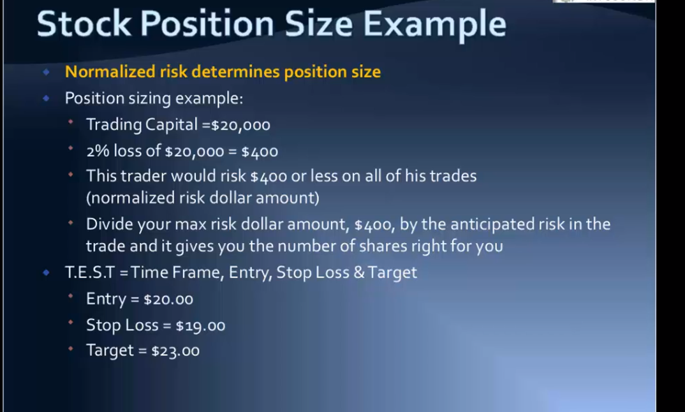

Example 2

Trading 75000

Entry -stop =risk

Entry – target is = reward

How many shares do I purchase

It’s the amount you are willing to risk/ risk per share of the trade

We are risking 2.50 per share……. Entry -stop =risk/1500 =600.

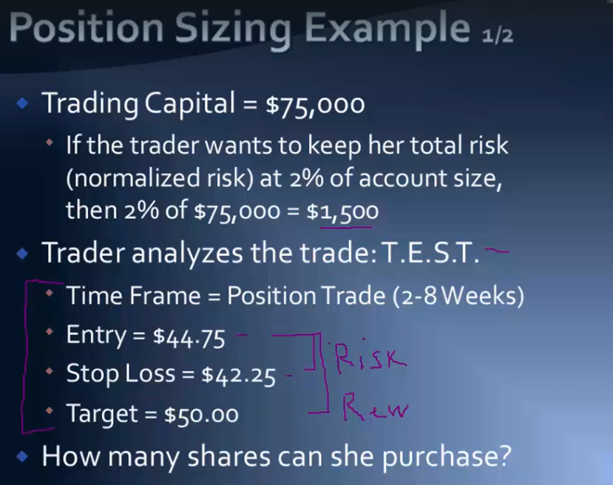

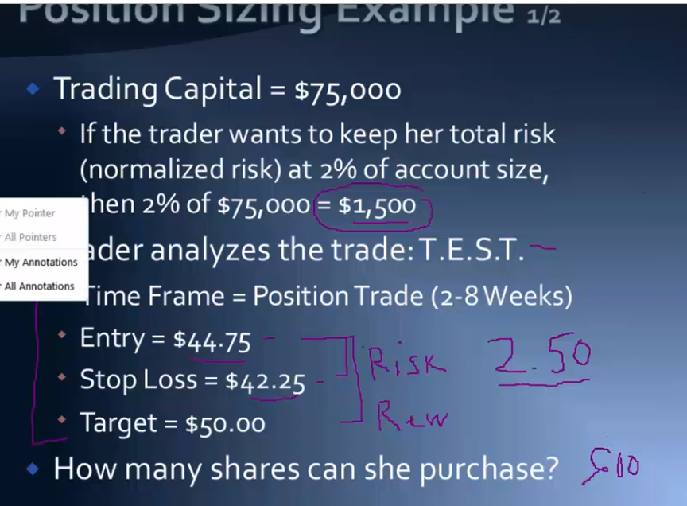

600

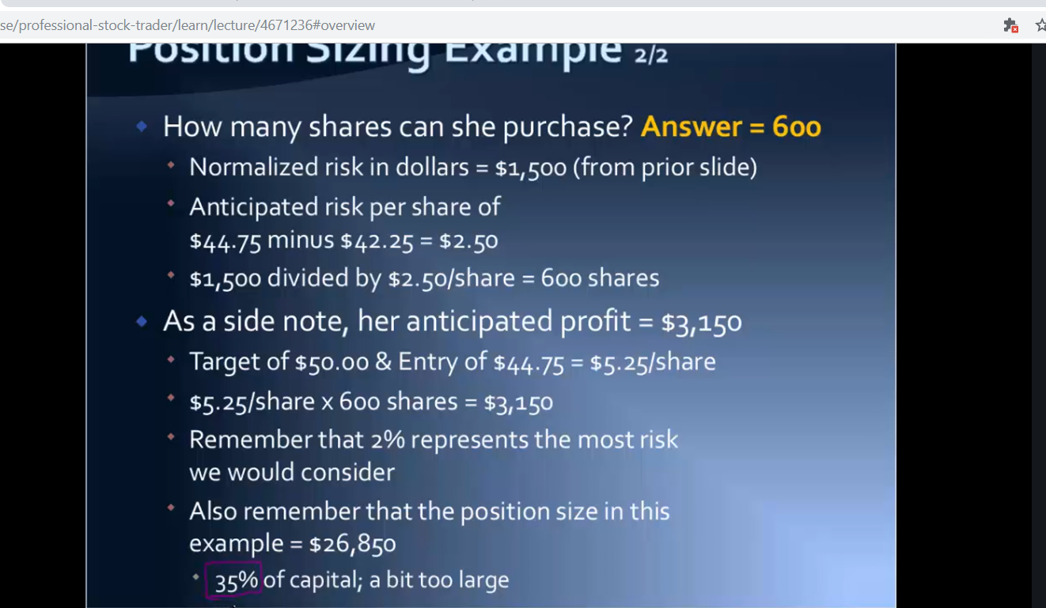

Pay attention to risk. Risk must

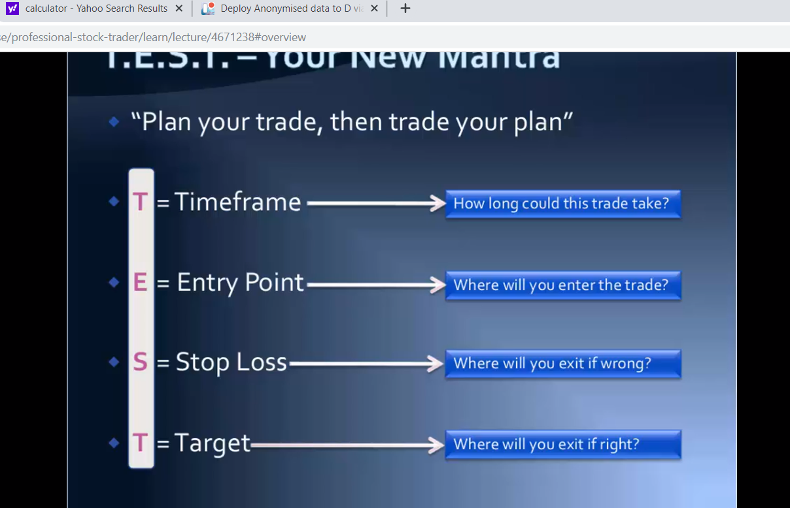

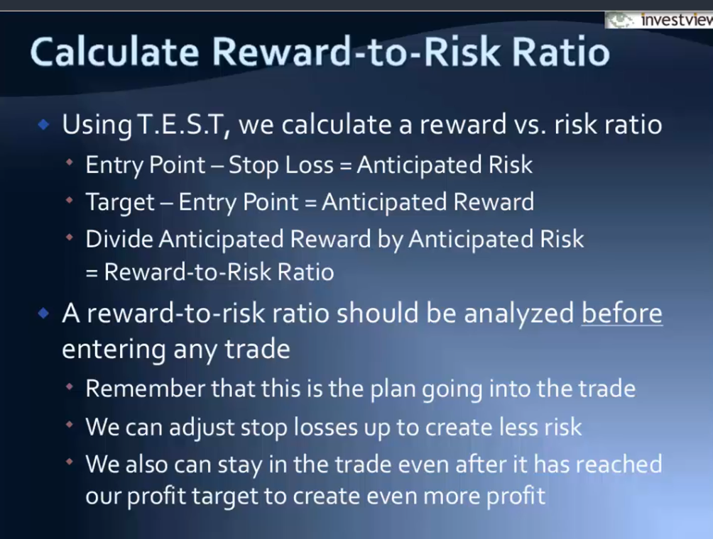

Use investview its at the end of the course so use this to your advantages

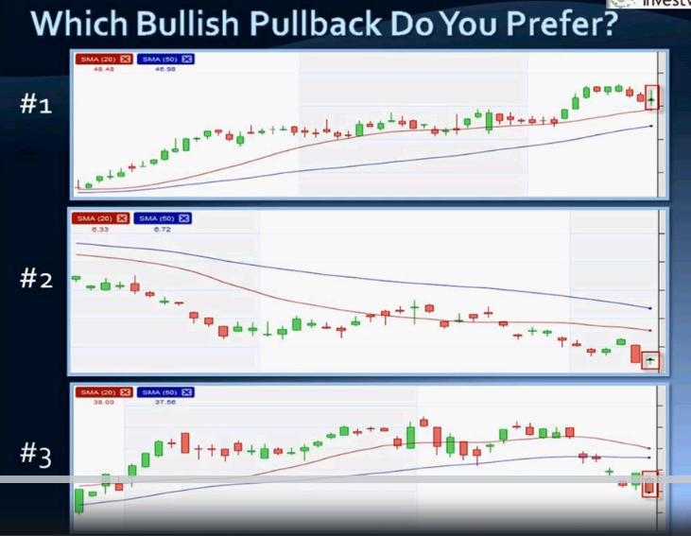

Which do you prefer which has more volume and momentum, quality filter which should show what we need to see.

Number 2 no way.

Number 3 has bearish candle at the end

Number 1 is the pull back to buy because it is an up trend

